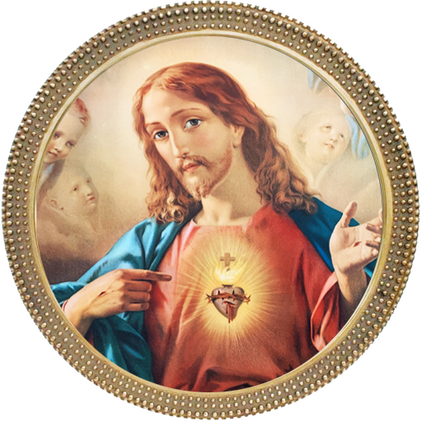

Jesus Christ

Our Guiding Force

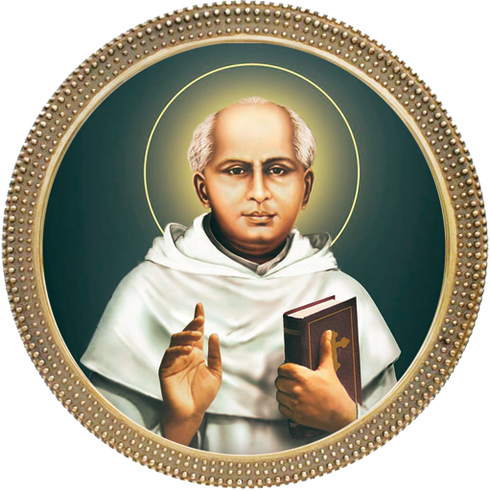

Saint Kuriakose Elias Chavara

Our Inspiration

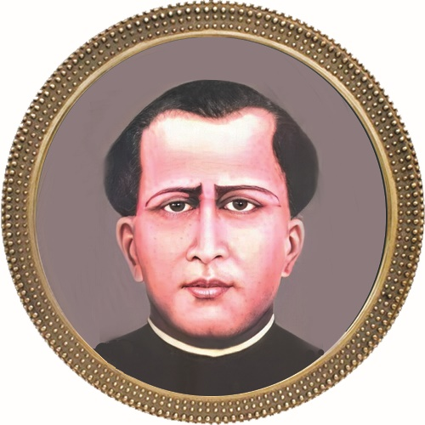

Fr. Thomas Porukara

Our Patron